Memorandum
TO: Elaine Murakami, FHWA
FROM: Laura McWethy
DATE: August 25, 2009
RE: LEHD OnTheMap v3.X on the VirtualRDC Documentation

This memo documents the Longitudinal Employer-Household Dynamics (LEHD) OntheMap (OTM) synthetic data found on the Cornell VirtualRDC website. It supplements the existing documentation for v2 which gives further information on the background of the data, and can be found here: http://www.vrdc.cornell.edu/onthemap/doc/otm_public_master.pdf Additional documentation which describes the restructuring of the files for v3 can be found here: http://www.vrdc.cornell.edu/onthemap/data/v3/notes-otm-v3.0.pdf. This memo covers how to access the data, what data are available, and how to work with the data.
For information on the steps used to synthesize this “home-to-work” flow using the Quarterly Census of Employment and Wages (QCEW), Unemployment Insurance (UI), and Federal StARS (Federal administrative records systems that includes IRS, Medicare, Medicaid, VA, etc), please read:
- The LEHD Infrastructure Files and the Creation of the Quarterly Workforce Indicators (Technical Paper No. TP-2006-01, dated December 5, 2005) by John M. Abowd, Bryce E. Stephens, Lars Vilhuber, Fredrik Andersson, Kevin L McKinney, Marc Roemer, and Simon Woodcock http://lehd.did.census.gov/led/library/techpapers/tp-2006-01.pdf
- Understanding LEHD and Synthetic Home to Work Flows in "ON THE MAP" May 2007, by Elaine Murakami: http://www.fhwa.dot.gov/planning/census/lehdonthemap.htm
- Papers that address worker populations who are not included in the LEHD OnTheMap, including self-employed and “informal” workforce. http://lehd.did.census.gov/led/library/techpapers_2007.html

Accessing OnTheMap Data
As stated in the v2 documentation, to access the OTM data users must apply for a download account on the VirtualRDC website, which can be done by contacting the VirtualRDC administrators (virtualrdc@cornell.edu). Access is open to anyone using the data for research purposes, with the user providing comments, analysis, feedback, and/or published papers.
Once users have a download account, they can go to the OTM download area (http://vrdc.ciser.cornell.edu/onthemap/data/), and enter in their user name and password. Once there, users will see the screenshot in Figure 1. The v2 data contains data for 42 states for the years 2002-2004. The v3 data contains data for all 50 states, the District of Columbia, Puerto Rico, and the Virgin Islands for the years 2002-2006. It should be noted that currently not all states contain all data file types in v3, as three of the four data types are only available for states participating in the LEHD program. States with missing data types include CT, DC, MA, NY, OH, PR, and VI. According to the v3 documentation, the files are continuously being updated, and additional data files will be counted as additional implicates. As this is the case, a 2006 data file the user may download currently may differ from the 2006 data file the user may download in the future.
Clicking on the v3/ link, which is circled in blue in Figure 1, will lead to a list of states with data. Users can then select which state they would like to analyze, which will bring up a list of types of data files available for that state. Clicking on the type of data file to be analyzed will bring up the files which can be downloaded. The data files are discussed in the next section.
NOTE: Because of the fine geographic detail, the files are large. For example, for 2006 LEHD OnTheMap, the OD file for the State of Texas took 445 MB amount of space (file tx_od_main_jp_2006_1.csv). For analytic purposes, you may want to aggregate the results by tract. Care must also be taken when analyzing the data at the block level due to coding errors from the residence and workplace geocoding systems, as well as misreporting by employers. The v2 documentation recommends aggregating to the Traffic Analysis Zone (TAZ) or Census tract level for accurate results.
Figure 1. OnTheMap Download Area
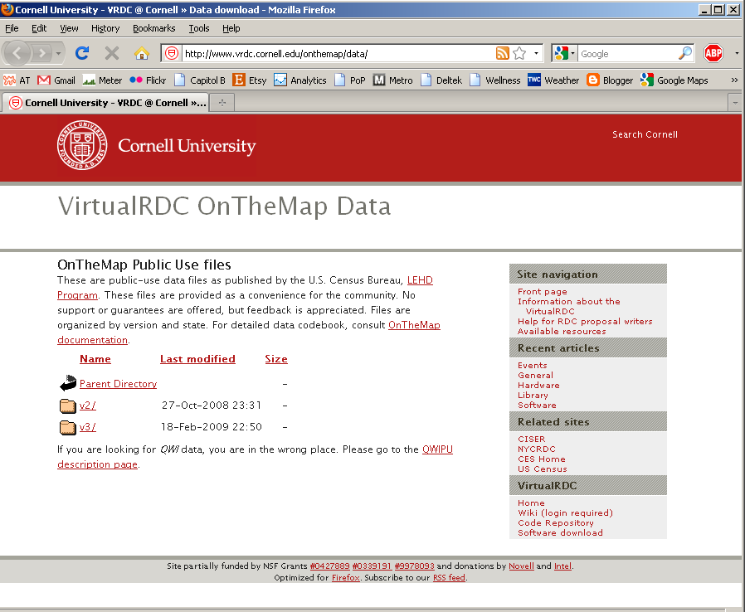

Data Files Description
There are four types of data files available in the v3 OTM data. These include Origin-Destination Matrix files (OD), Quarterly Workforce Indicators files (QWI), Residence Area Characteristics files (RAC) and the Workplace Area Characteristics files (WAC). As found in the documentation for the v3 data, the file naming convention is as follows for each type of file:

RAC/WAC files:
<state>_<type>_<indgrp>_<jobtype>_<year>_<implicate>.csv
QWI files:
qwi_<state>_<year>.csv
OD files:
<state>_od_<filetype>_<jobtype>_<year>_<implicate>.csv
where
<state>: two-letter lower-cast postal abbreviation, denoting the place of work.
<type>: ‘rac’ or ‘wac’.
<filetype>: ‘main’ or ‘aux’. The main file contains “All jobs with jobholder’s place of residence IN the state”, the aux file contains “All jobs with jobholder’s place of residence OUT of the state”.
<indgrp>: Labor market segments
<jobtype>: ja, (Jobs All), jp (Jobs Primary), pa (Private All), and pp (Private Primary).
<year>: 2002-2006
<implicate>: implicate number (currently fixed at 1, other implicates pending).

Note: For the jobtype, the first letter indicates whether it is all jobs including both private and government jobs (j) or private jobs (p), and the second letter indicates whether it is the primary job, which is the highest paying job (p) or all jobs, with the possibility of multiple jobs per worker (a).

The first type of files are the OD files, which link the residence block with the employment block, and are useful for analyzing worker flows. The OD files for v3 differ from the v2 files, and contain the variables as shown in Table 1.

Table 1. OD File Variable Definitions

Variable | Definition
w_geocode | FIPS State - FIPS County - Census Tract - Census Block Group for workplace block group
h_geocode | FIPS State - FIPS County - Census Tract - Census Block Group for residence block group
total | Total number of workers for that OD pair
age1 | Number of workers age 30 or less
age2 | Number of workers age 31-54
age3 | Number of workers age 55 or older
earn1 | Number of workers earning $1,200 or less per month
earn2 | Number of workers earning $1,201 to $3,400 per month
earn3 | Number of workers earning more than $3,400 per month
ind1 | Number of workers in Goods Producing: NAICS 11, 21, 23, and 31-33
ind2 | Number of workers in Trade Transportation and Utilities: NAICS 42, 44-45, 48-49, and 22
ind3 | Number of workers in All Other Services: remaining NAICS
createdate | Indicates the calendar date when data set was created

The second type of files are the QWI files, which describe characteristics of a block such as average earnings employment, number of establishments, job creation, job destruction, and other characteristics. The variables found in these files are shown in Table 2.
Table 2. QWI File Variable Definitions

Variable | Definition
w_geocode | FIPS State - FIPS County - Census Tract - Census Block Group for workplace
B | Beginning of period employment
F | Full-quarter employment
JC | Job creation
JD | Job destruction
H3 | Full-quarter new hires
Z_W3 | Average earnings of full-quarter employees
Z_WFS | Average earnings of separations from full-quarter status
Z_WH3 | Average earnings of full-quarter new hires
status_B | Status: beginning of period employment
status_F | Status: full-quarter employment
status_JC | Status: job creation
status_JD | Status: job destruction
status_H3 | Status: Full-quarter new hires
status_M | Status: flow employment
status_Z_W3 | Status: average earnings of full-quarter employees
status_Z_WFS | Status: average earnings of separations from full-quarter status
status_Z_WH3 | Status: average earnings of full-quarter new hires
M | Flow employment
FS | Separations from full-quarter status
n_M | Number of establishments
status_FS | Status: separations from full-quarter status
createdate | Indicates the calendar date when data set was created

The last two types of data are similar, which include the RAC and the WAC files. These data files include the number of workers by industry, age, and income level in each block, for the residence end and the workplace end, respectively. The variables found in these files are shown in Table 3.
Table 3. RAC and WAC File Variable Definitions

Variable | Definition
h_geocode / w_geocode | FIPS State - FIPS County - Census Tract - Census Block Group for residence block group or work place block group
total | Total number of workers in the block group
age1 | Number of workers age 30 or less
age2 | Number of workers age 31-54
age3 | Number of workers age 55 or older
earn1 | Number of workers earning $1,200 or less per month
earn2 | Number of workers earning $1,201 to $3,400 per month
earn3 | Number of workers earning more than $3,400 per month
naics_s01 | Count of jobs in Agriculture, Forestry, Fishing and Hunting (NAICS 11)
naics_s02 | Count of jobs in Mining (NAICS 21)
naics_s03 | Count of jobs in Utilities (NAICS 22)
naics_s04 | Count of jobs in Construction (NAICS 23)
naics_s05 | Count of jobs in Manufacturing (NAICS 31-33)
naics_s06 | Count of jobs in Wholesale Trade (NAICS 42)
naics_s07 | Count of jobs in Retail Trade (NAICS 44-45)
naics_s08 | Count of jobs in Transportation and Warehousing (NAICS 48-49)
naics_s09 | Count of jobs in Information (NAICS 51)
naics_s10 | Count of jobs in Finance and Insurance (NAICS 52)
naics_s11 | Count of jobs in Real Estation and Rental and Leasing (NAICS 53)
naics_s12 | Count of jobs in Professional, Scientific, and Technical Services (NAICS 54)
naics_s13 | Count of jobs in Management of Companies and Enterprises (NAICS 55)
naics_s14 | Count of jobs in Administration, Support, Waste Mngt, and Remediation Services (NAICS 56)
naics_s15 | Count of jobs in Educational Services (NAICS 61)
naics_s16 | Count of jobs in Health Care and Social Assistance (NAICS 62)
naics_s17 | Count of jobs in Arts, Entertainment, and Recreation (NAICS 71)
naics_s18 | Count of jobs in Accomodation and Food Services (NAICS 72)
naics_s19 | Count of jobs in Other Services (except Public Administration) (NAICS 81)
naics_s20 | Count of jobs in Public Administration (NAICS 92)
createdate | Indicates the calendar date when data set was created

Working with OnTheMap Data
This section contains sample SAS code for working with OTM files. The first sample code is for importing files into SAS once they are downloaded to the user’s computer. The file type shown in the sample is for an OD file, but it will work for all four types once the file name is adjusted.

Sample SAS code for importing OTM files

proc import datafile="D:\ <state>_od_<filetype>_<jobtype>_<year>_<implicate>.csv”
out=OTM. <state>_od_<filetype>_<jobtype>_<year>_<implicate>
dbms=csv replace;
getnames=yes; /* getnames = no if data on row 1*/
run;

One useful calculation that can be done with the OD files is to find the commute trip length distributions. This cannot be done only with the OTM files, but first a distance file must be created using ArcGIS for whatever geography level is chosen (in this case, tract-to-tract). The process to create the distance file using the Census boundary files available on the Census website (http://www.census.gov/geo/www/cob/bdy_files.html) is described below. This process may not be the most efficient, but it creates the file correctly. All of these calculations were done using ArcInfo.
Step 1 – Create Centroid point shape files for the tracts in GIS, as shown in Figure 2.
Add Census shape files to map
Create Centroid shape file using Feature to Point tool (found in: data management, features, feature to point)
Figure 2. Creating Tract Centroid Shape File
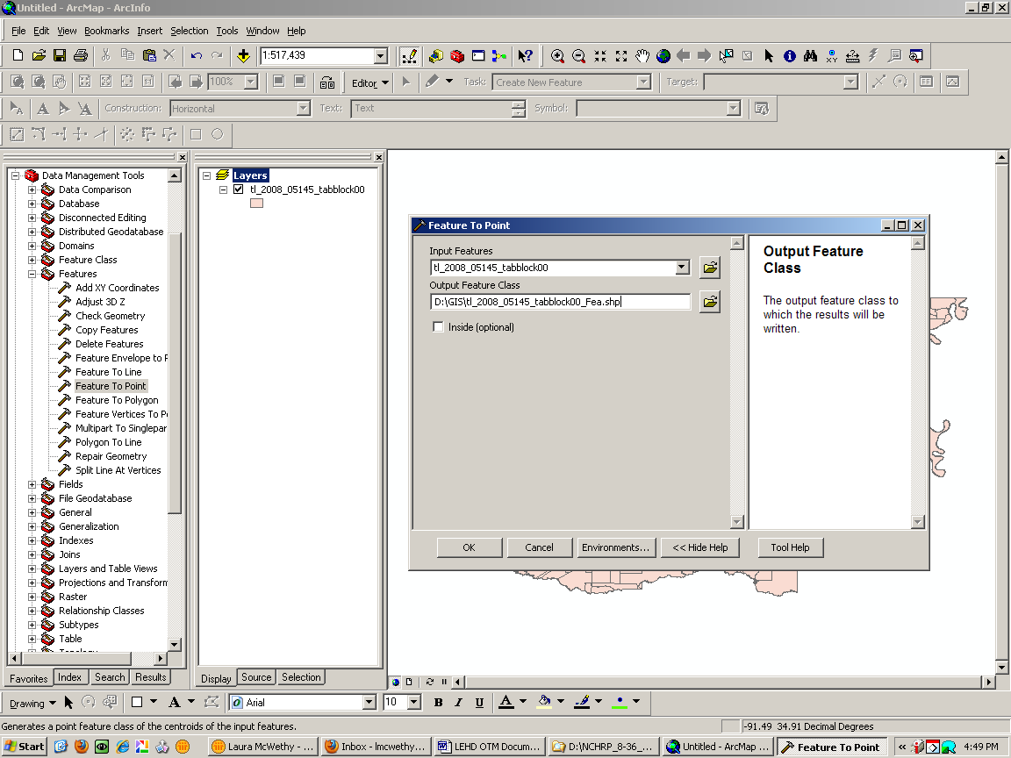
Step 2 – Calculate the distances between the centroids in GIS, as shown in Figure 3.
Point Distance tool (found in: analysis, proximity, point distance)
Input Feature = tract centroid file
Near Feature = tract centroid file
Figure 3. Calculating Distances between Tract Centroids
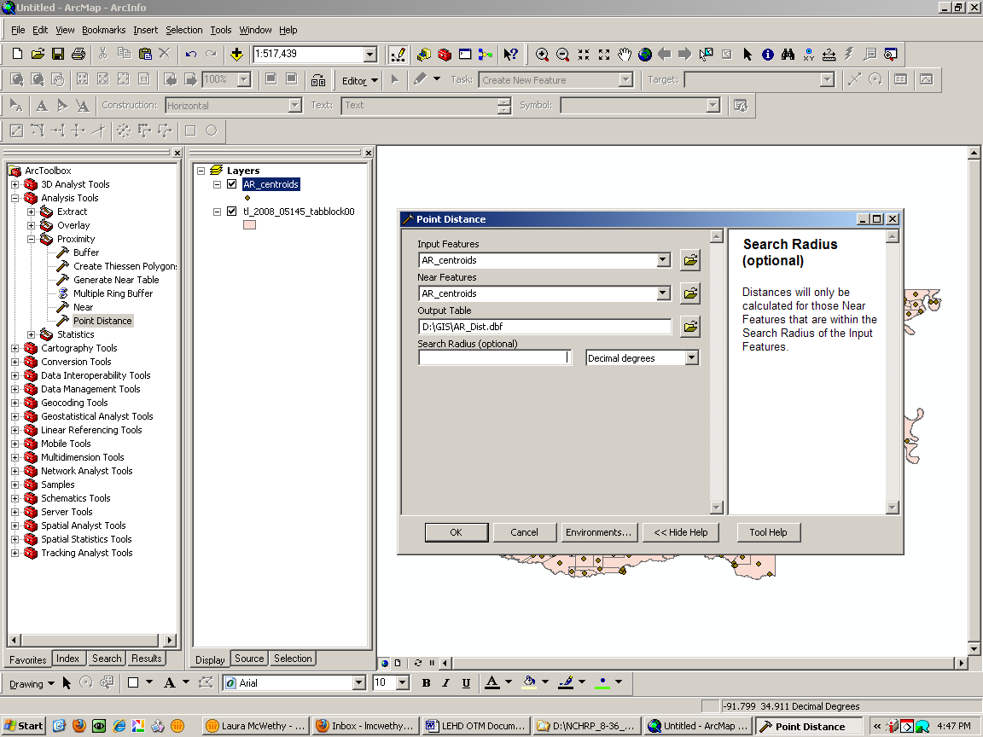
This step is computationally heavy, and it may be necessary to limit the number of distances calculated. This can be done by specifying a search radius, as seen in the dialog box.
Step 3 – Add Tract Ids to distance file
Add 3 new text variables, Tract_A, Tract_B, and OD, and a double variable, as seen in Figure 4.
Figure 4: Adding New Variables
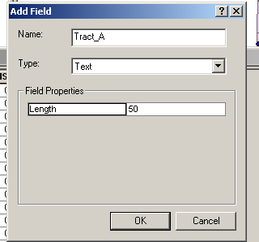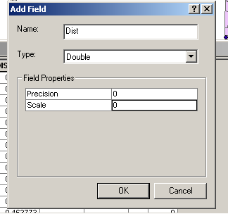

Join tract centroid file to distance file using Input FID, as seen in Figure 5.
Figure 5: Joining Tract Centroid File to Distance File
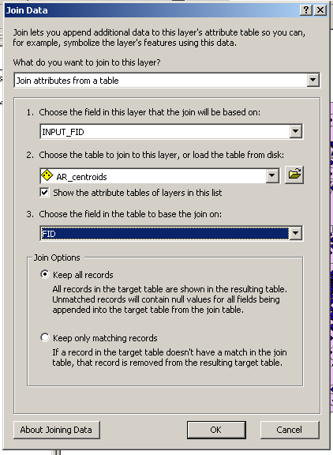
Calculate Tract_A=State & County & Tract
Remove tract centroid file join and repeat tract centroid join, using Near FID instead of Input FID.
Calculate Tract_B = State & County & Tract
Remove State centroid file join
Calculate OD = Tract_A&”-“&Tract_B
The output from Step 3 is a dbf file containing the Tract Ids and the distances. The sample script below reads in the distance file and the OTM OD file and calculates the commute trip length distributions. The user must make sure all the files and libraries are correctly named in the script for it to run.

Sample SAS code for Calculating Commute Trip Length Distributions
* Step 1 - Import distance files;

PROC IMPORT OUT= DIST.Dist_AR
DATAFILE= "S:\OTM\AR_Dist.dbf"
DBMS=DBF REPLACE;
GETDELETED=NO;

Proc Sort data=dist.dist_ar;
by OD;
run;

* Step 2 - Create OD files;

proc import datafile="S:\OTM\ar_od_main_jp_2006_1.csv"
out=OTM.ar_OD
dbms=csv replace;
getnames=yes; /* getnames = no if data on row 1*/
run;
Data OTM.ar_work;
set OTM.ar_od;
Keep OD Tract_W Tract_H County_W Total;
Tract_W=floor(w_geocode/10000);
Tract_H=floor(h_geocode/10000);
County_W=floor(w_Geocode/10000000000);
County_H=floor(h_Geocode/10000000000);
OD=Tract_H||'-'||Tract_W;
if (County_W=5145) then output OTM.ar_Work;

Proc Sort data=OTM.ar_work;
by OD;
run;

proc summary data=OTM.ar_work;
by OD;
var total;
output out=OTM.ar_Tract
SUM= total;
run;

*Step 3 - Merge OD and Distance Files;

Data sum.ar_work;
keep OD total dist;
update otm.ar_tract Dist.dist_ar;
by OD;
if(dist=. or total=.) then delete;
run;

data sum.ar_work_cat;
set sum.ar_work;
if(dist<1) then Dist_Cat=1;
if(Dist=>1 and Dist<5) then dist_Cat=2;
if(Dist=>5 and Dist<10) then dist_Cat=3;
if(Dist=>10 and Dist<15) then dist_Cat=4;
if(Dist=>15 and Dist<20) then dist_Cat=5;
if(Dist=>20 and Dist<25) then dist_Cat=6;
if(Dist=>25 and Dist<30) then dist_Cat=7;
if(Dist=>30 and Dist<35) then dist_Cat=8;
if(Dist=>35 and Dist<40) then dist_Cat=9;
if(Dist=>40 and Dist<45) then dist_Cat=10;
if(Dist=>45 and Dist<50) then dist_Cat=11;
if(Dist=>50 and Dist<55) then dist_Cat=12;
if(Dist=>55 and Dist<60) then dist_Cat=13;
if(Dist=>60 and Dist<65) then dist_Cat=14;
if(Dist=>65 and Dist<70) then dist_Cat=15;
if(Dist=>70 and Dist<75) then dist_Cat=16;
if(Dist=>75 and Dist<80) then dist_Cat=17;
if(Dist=>80 and Dist<85) then dist_Cat=18;
if(Dist=>85 and Dist<90) then dist_Cat=19;
if(Dist=>90 and Dist<95) then dist_Cat=20;
if(Dist=>95 and Dist<100) then dist_Cat=21;
if(Dist=>100) then dist_Cat=22;
run;

Proc Sort data=sum.ar_work_cat;
by dist_cat;
run;

proc summary data=sum.ar_work_cat;
by Dist_Cat;
var total;
output out=sum.ar_Work_Sum
SUM= total;
run;

PROC EXPORT DATA= sum.ar_work_Sum
OUTFILE= "S:\OTM\Trip Length Freq.xls"
DBMS=EXCEL REPLACE;
SHEET="ar";
RUN;

