Downloading Census Geographies and Associated PL94-171 Population Data Using the Geography Network’s TIGER 2000 Download Service

Copyright © 2001 ESRI, Inc.

Data from the 2000 Census is available at no cost from the Geography Network’s TIGER 2000 Download Service. Two basic types of files are available from the TIGER 2000 Service: geographic features (for example, boundaries, streets, rivers) and demographic data (for example, population statistics). To map census data using GIS software, you must download geographic features and the corresponding demographic data. This document walks you through the process of downloading first the geographic features and then the demographic data for an area of your choosing.
1
Navigate to http://www.geographynetwork.com/data/tiger2000/index.html using your Web browser. Do one of the following:
- If you are already a registered user of the TIGER 2000 Download Service, type your e-mail address in the text box and click the Enter button.
- If you are not a registered user, click the Register to Download Now! link. Fill out the registration form and click the Submit Information button.
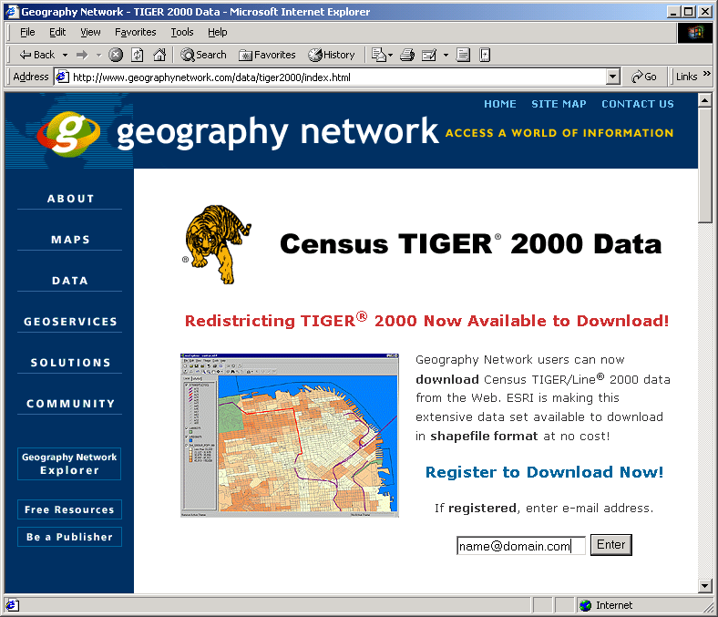
1
Choose a state from the dropdown list or by clicking on the map.
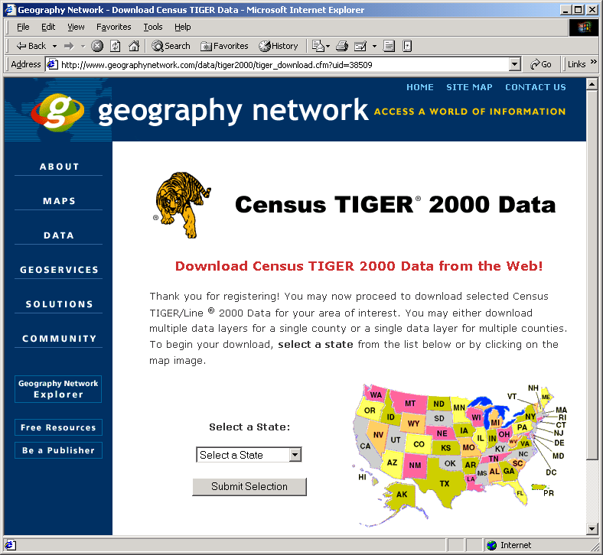
2
2

Do one of the following:
3
- If you want to work with all TIGER 2000 geographic files for a specific county, choose the desired county from the Select by County dropdown list and click the Submit Selection button.
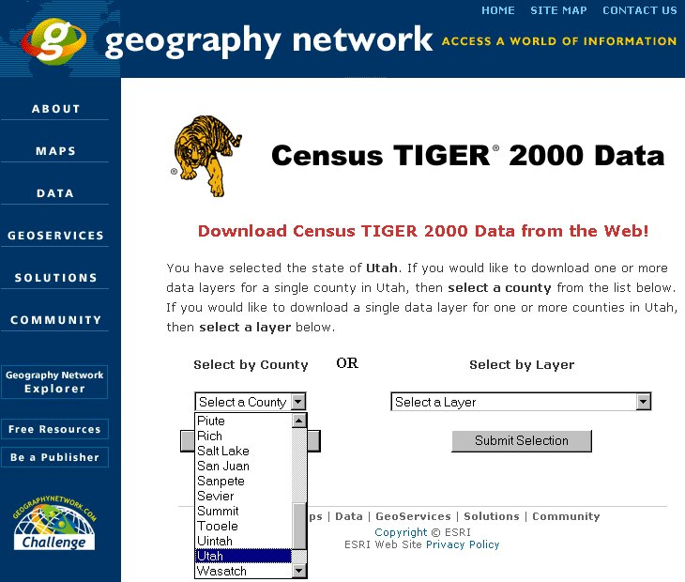
3
- If you want to select data by layer, choose a layer from the Select by Layer dropdown list and click the Submit Selection button.
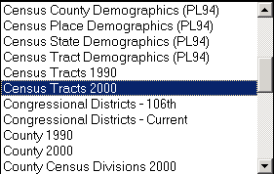
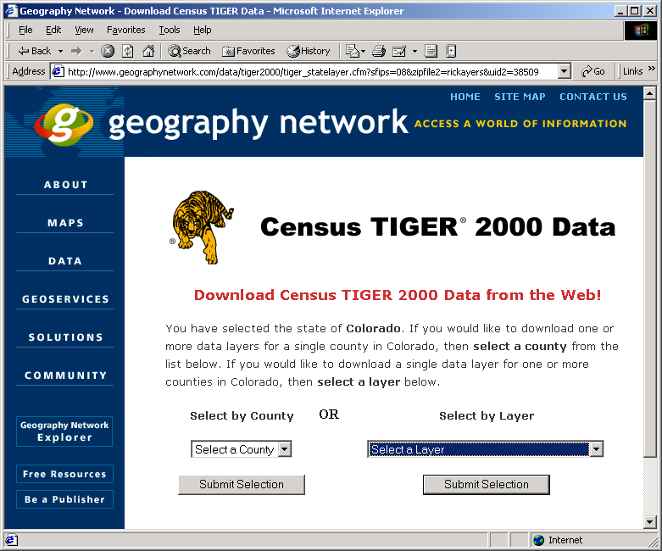
3

The next page indicates which data layer or county you have selected (highlighted in blue below). Do one of the following:
4
- If you selected a county in the previous step, check All Data Layers or check the individual layers you want.
- If you selected a layer in the previous step, check the county or counties for which you want to download a layer. You have the option of downloading all counties if the total file size does not exceed 20MB.
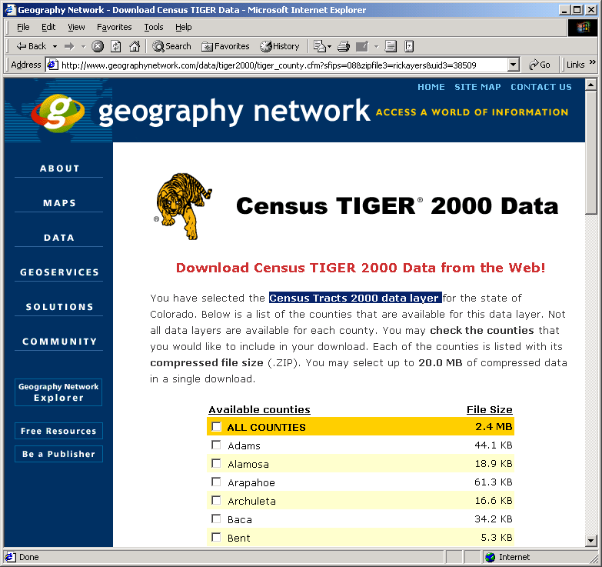
Scroll to the bottom of the page and click the Proceed to Download button.
4
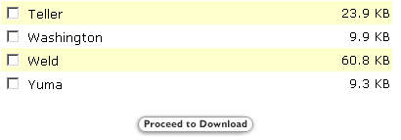
Click the Download File Now! button to download a ZIP file of shapefiles. Save the file on your local machine.
5
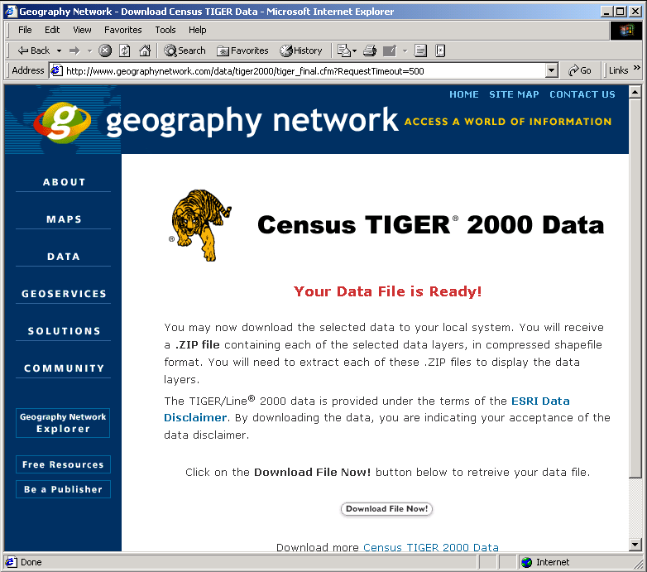
5
6
Click the Back button on your Web browser until you get to the page shown below. From the Select by Layer dropdown list, choose the demographic (PL94) data that corresponds to the geography that you have just downloaded. Click the Submit Selection button. Check the data you want to download and click the Proceed to Download button.
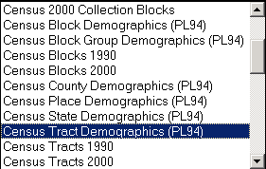
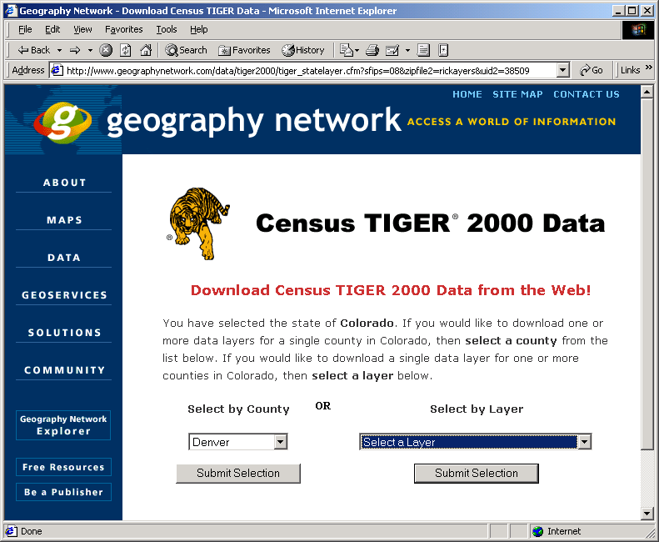
6
In ArcView 3.x or ArcGIS, perform an attribute join based on the common geographic code.
7
If you chose to download all geographic files for a specific county, note that the demographic file includes data for the entire state (for example, all census tracts) while the county geographic file includes only those census tracts in its boundaries. When joining these two files using the common geographic code, only the demographic data for the tracts inside the county in question will be appended to the county geographic file of tract boundaries. If you want to avoid performing this step again, consider converting the joined files to a shapefile.
Read all data documentation and readme files that accompany the downloads.
8
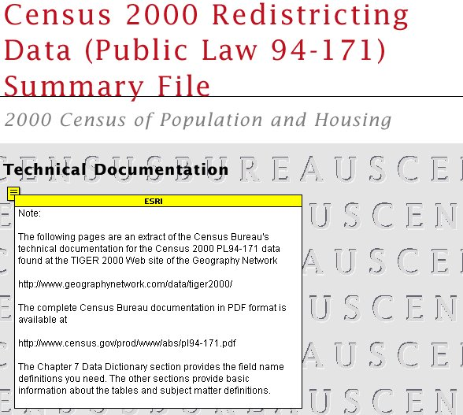
NOTE: Field name definitions (e.g., P00010001 = Total Population) are described in an abbreviated version of the Census Bureau’s PL94-171 technical documentation. This Adobe Acrobat document (pl94-171_abbrev.pdf ) is available at http://www.geographynetwork.com/data/tiger2000/ in the data documentation section.

Return to the TIGER 2000 site in the near future. ESRI will deposit additional data extracts from Census 2000 Summary File 1 (SF1).
9

